Some feedbacks for the TRACE website design:
- Remove this segment from homepage
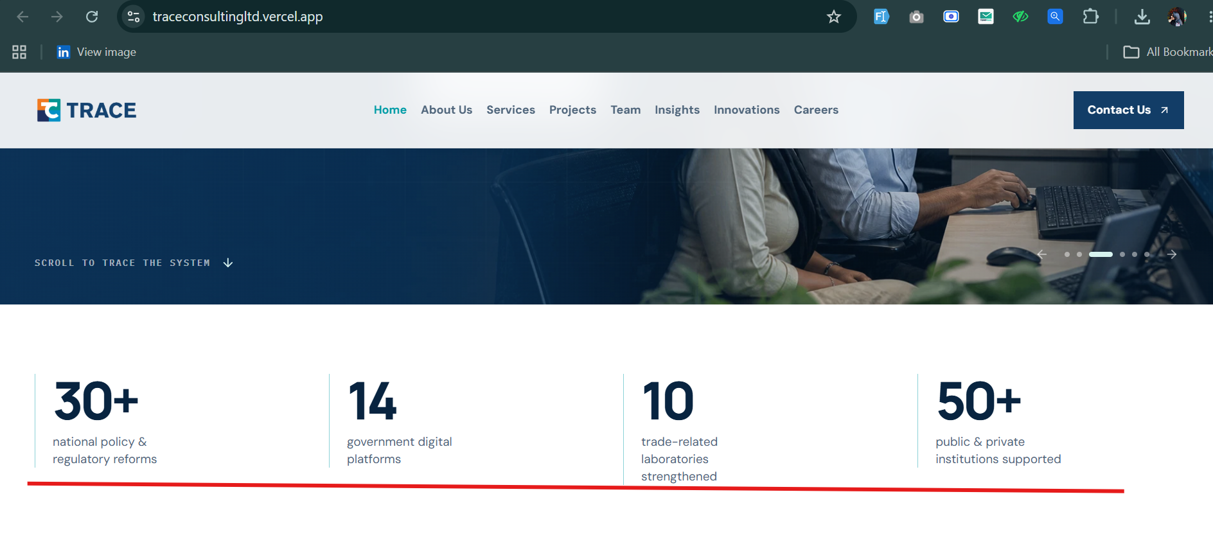
- This segment could benefit from a more creative and visually engaging presentation. We recommend exploring an alternative layout and structure to improve its overall visual appeal, readability, and user engagement.
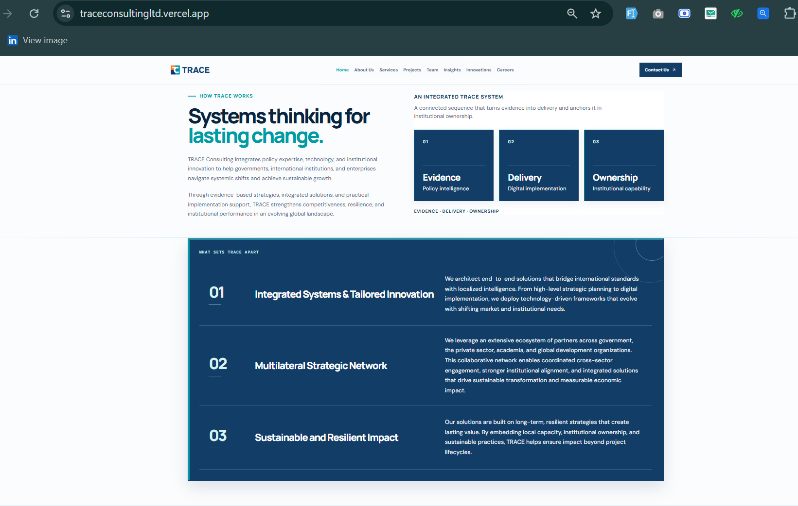
- Service section of the homepage should have small details of respective services like TRACE website (Current)
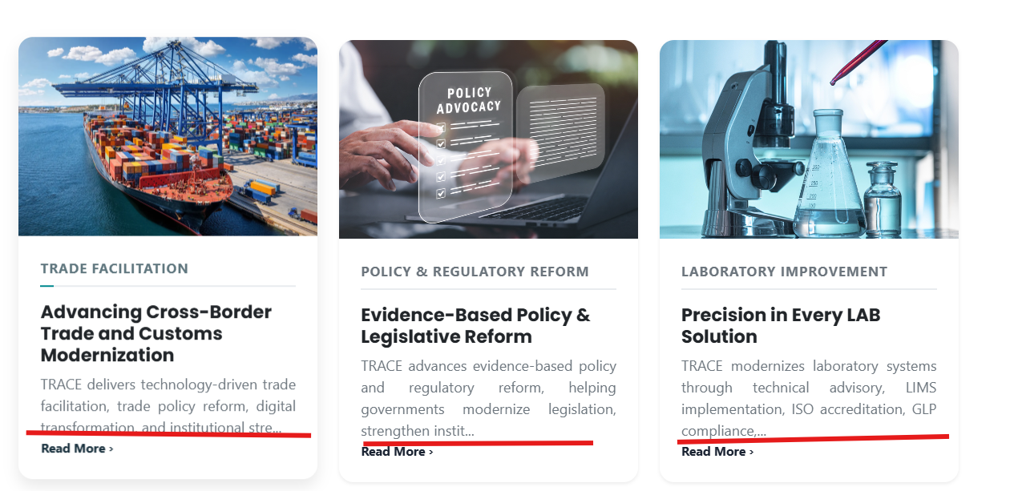
- Project section design looks alright but animation should be revised.
- In the about us section within the homepage, we should keep the Trace logo desk image
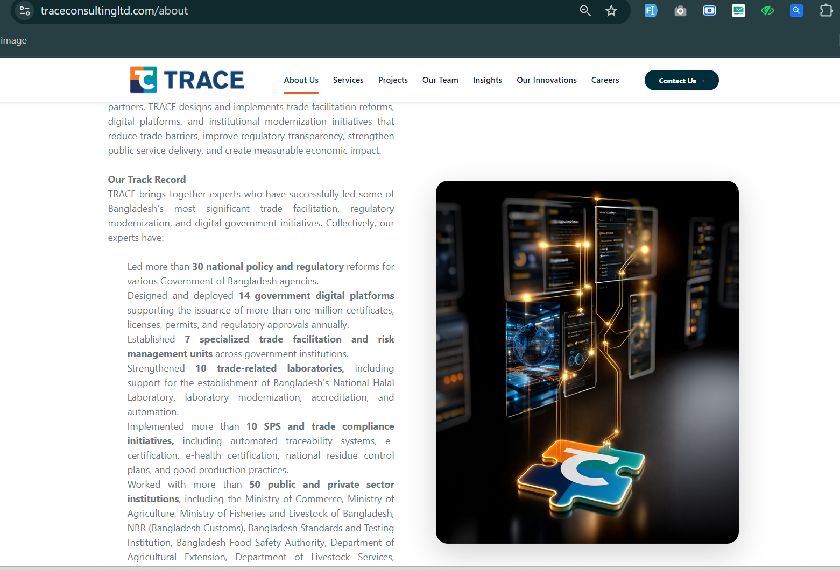
- If the insights section could be auto-animated just like the expert section is auto-scrolling in the homepage (explore more creative ways to present)
Other pages:
- Remove related projects section in Projects page
- People should not be able to apply in positions that have crossed deadline (Career page) also design the career page according to this
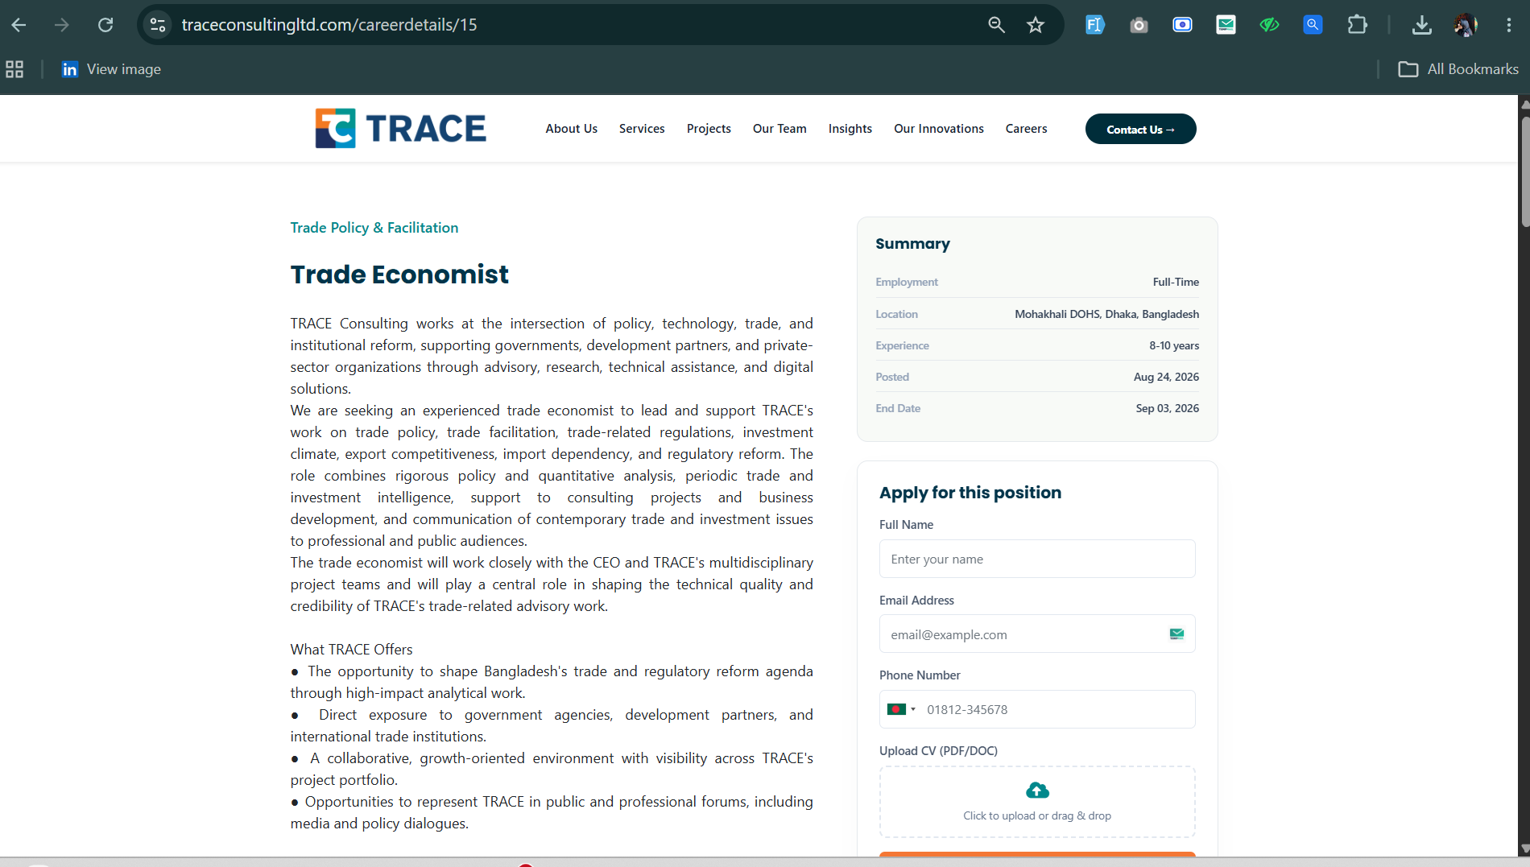

- Design the service details page in more creative way, try some new suitable outlet
